**TITLE:** ROOF

**LOGO:**



**ROOF**

**(Home Rental System)**

**Guided By :**

**Roles:**

|  |  |  |  |
| --- | --- | --- | --- |
| **Project Id** | **Name** | **Role** | **Mail Id** |
| **RE5962** | **Aditya Nair** | **Front End, Back End** | **adnair11@in.ibm.com** |
| **RE6037** | **Nihal Karadan** | **Front End, Back End** | **nkarada1@in.ibm.com** |
| **RE3806** | **Shruthy Annie Santhosh** | **Front End, Back End** | **srsanth1@in.ibm.com** |
| **RE9357** | **Arjoita Banerjee** | **Front End, Designing,**  **Documentation** | **arjbane1@in.ibm.com** |
| **RE2569** | **Satwinder Singh** | **Front End,**  **Documentation** | **Satwsin1@in.ibm.com** |
| **RE8831** | **Tania Kapoor** | **Front End,**  **Testing** | **tanikap1@in.ibm.com** |
| **RE5728** | **Piyush Darshan** | **Front End, Back End** | **Pdarsha1@in.ibm.com** |

**Abstract:**

In our day to day life with advancement in technology and fast lifestyle , tenants face a lot of issue in finding an appropriate place to rent. Also, property owners face issues in advertising their properties. In the emerging days, it will be very hard to rent buildings, villas, apartments etc. in metropolitan cities. This project provides facility to the user to search appropriate Residential property, view property. Through this the user can access information to buy or sell their properties online. Property owners can post their properties.

There would be features like login, registration, searching properties, managing properties, posting properties and booking properties.

1. **Analysis**

* Login as User
* Login Form

Username

Password

Sign in button

Forgot password link

* Registration form for new users

First name and Last name fields

E-mail

Contact number

City

State

Country

Pin code

Password

Security question

* Properties

Post Property

View Property details

Book Property

Search Property

**Use Case Diagram:**

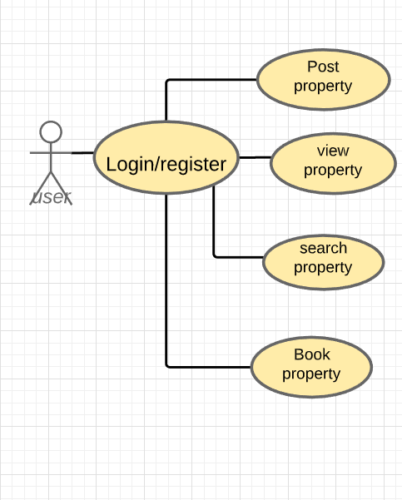

**Screenshots:**

1. HOME Page:

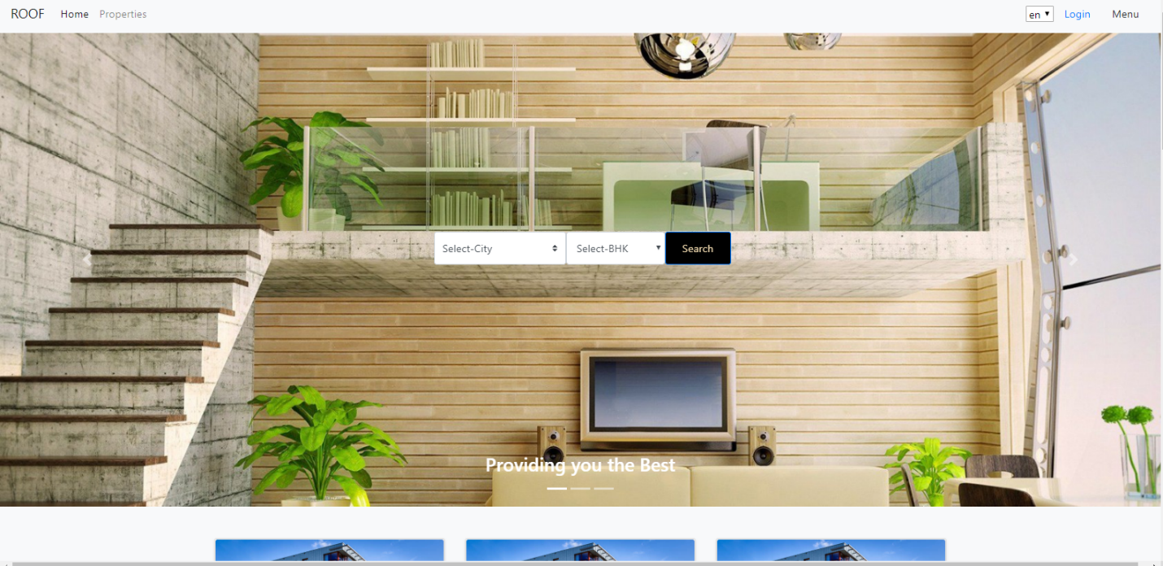

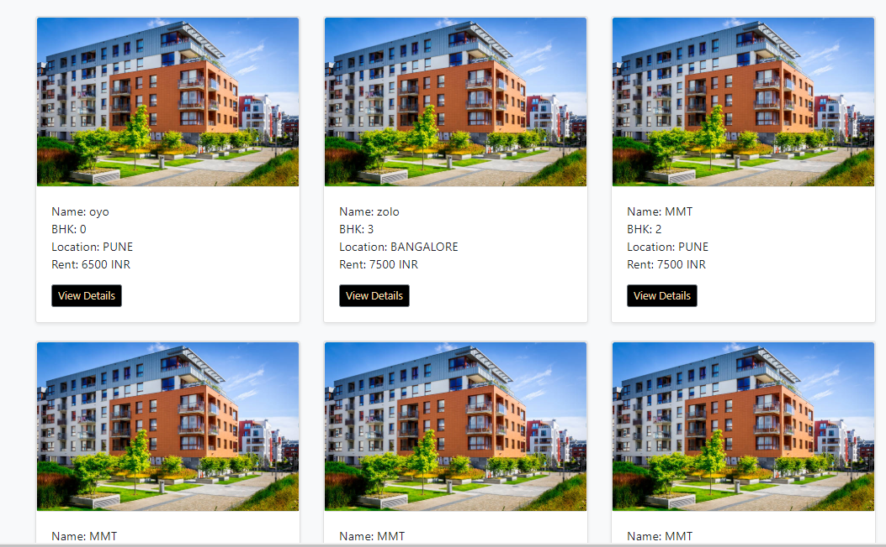

1. LOGIN Page:

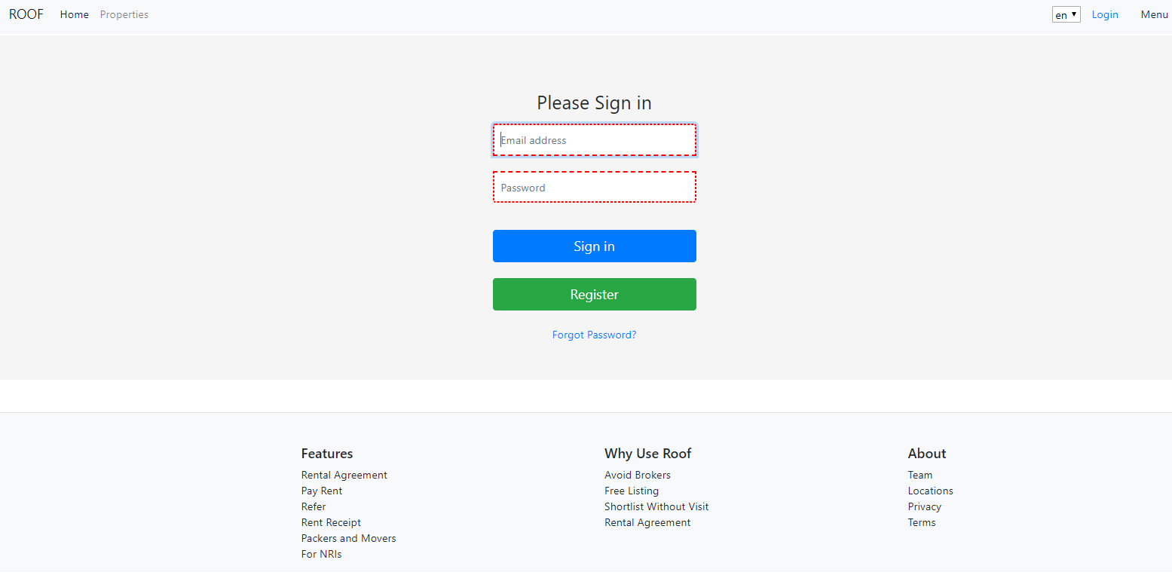

1. Register Page:

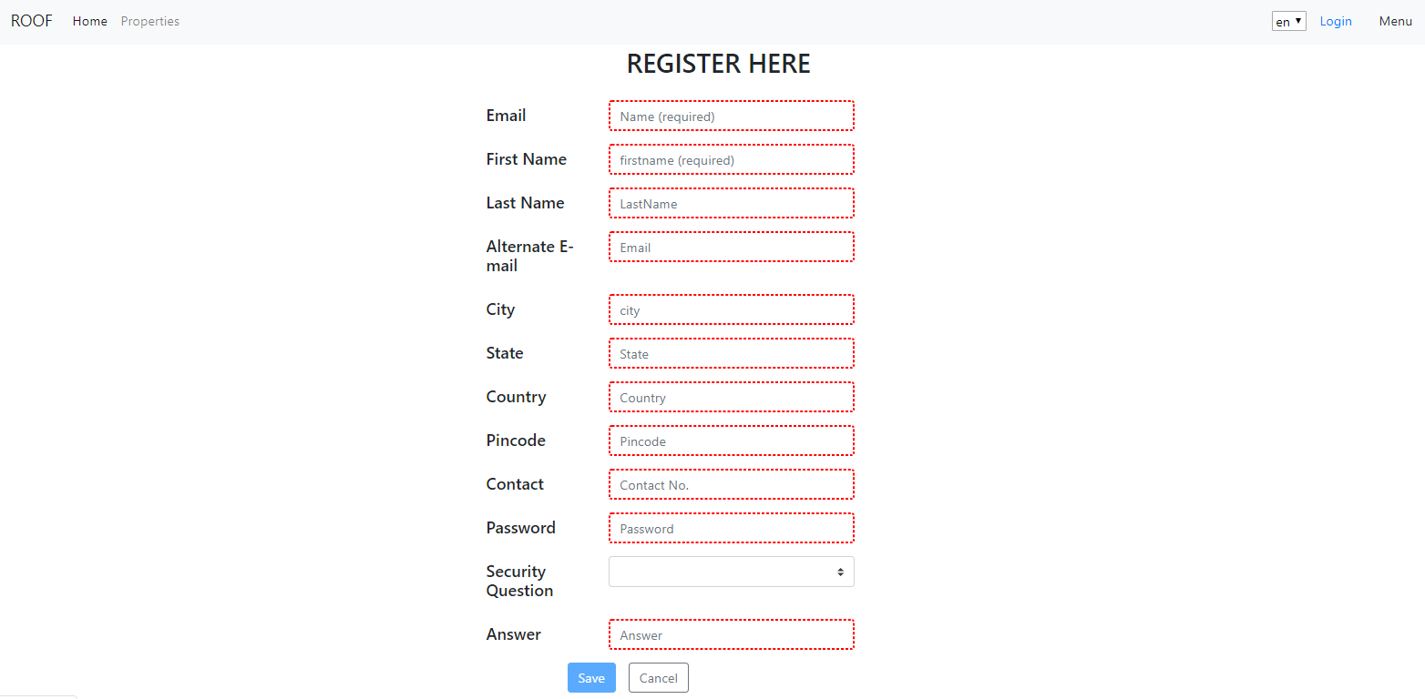

1. Forgot Password Page:

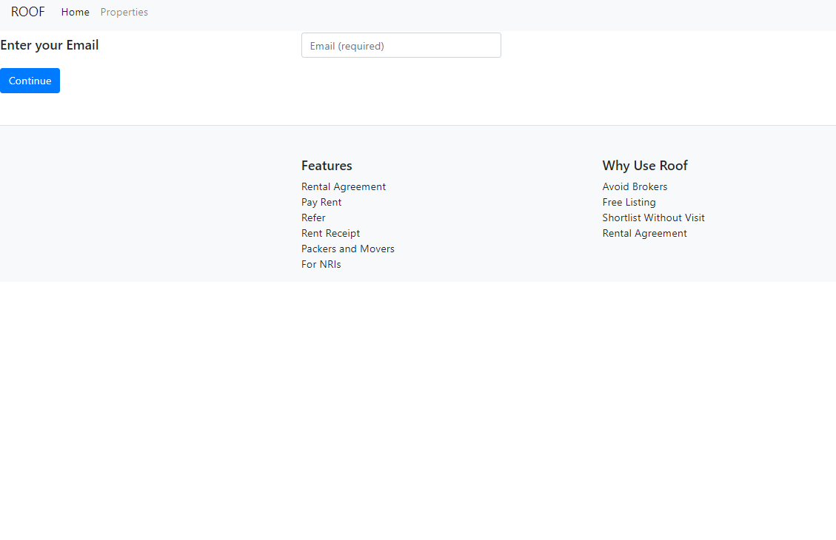

1. Internationalization:

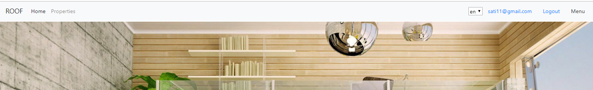

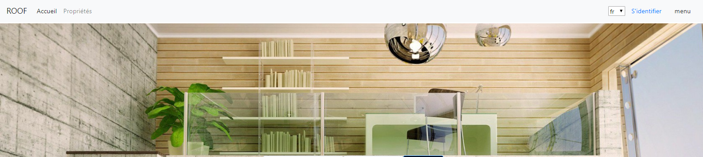

1. Properties Page:

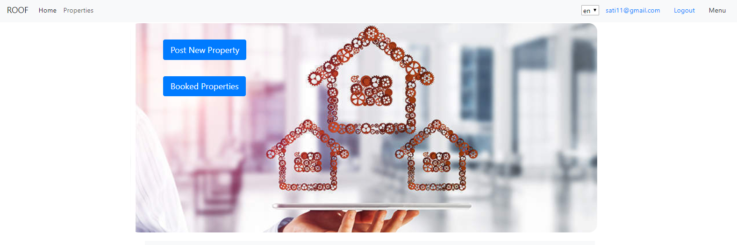

1. Post Property:

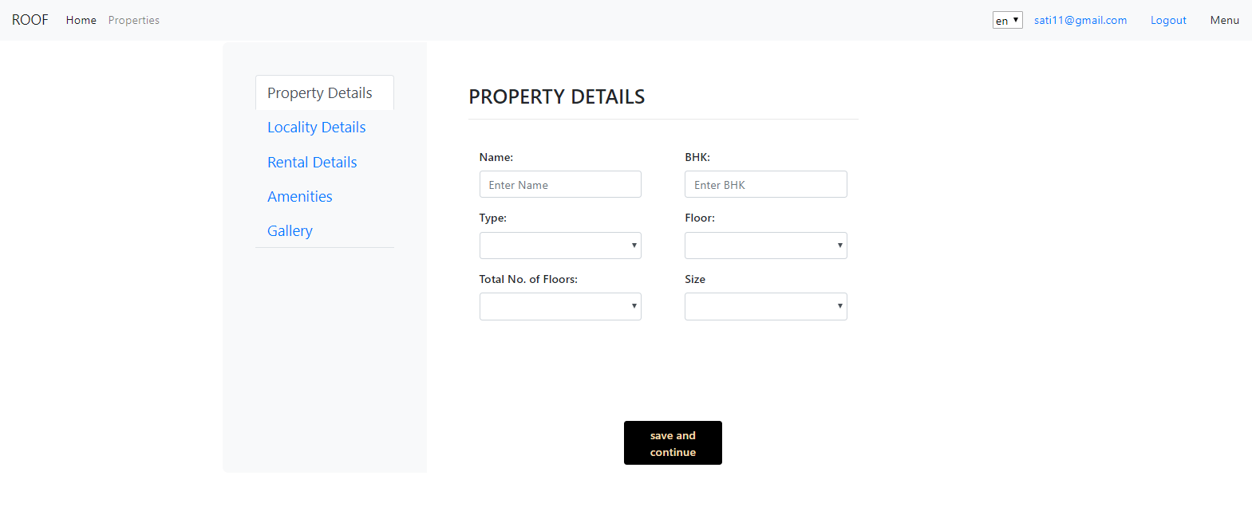

1. View Property Details:

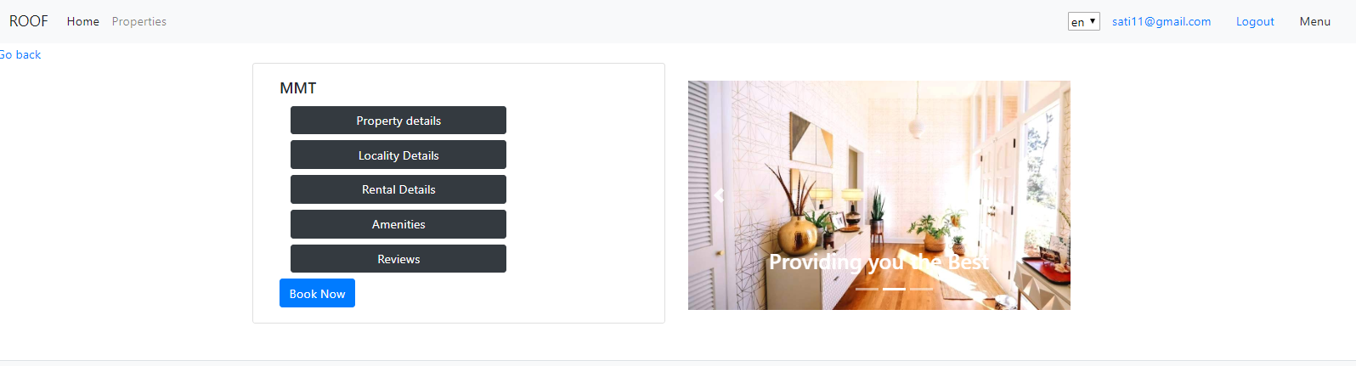

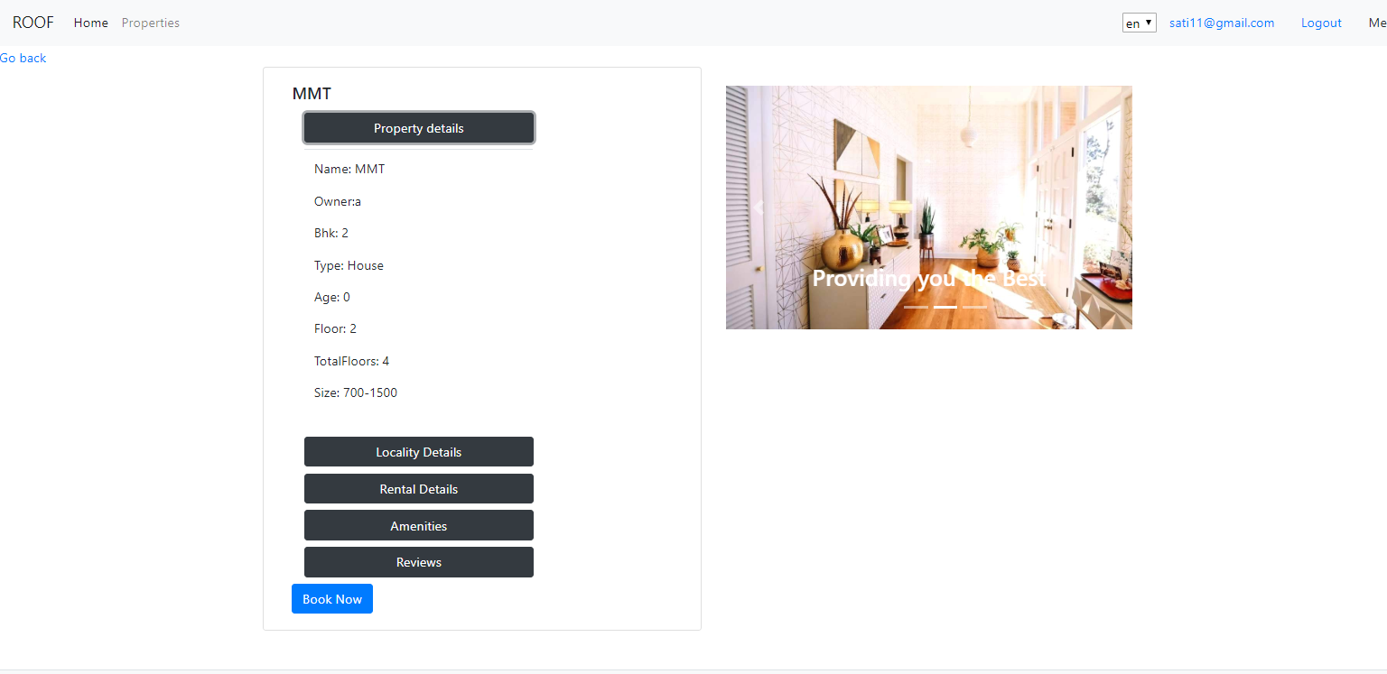

1. Rent Property:

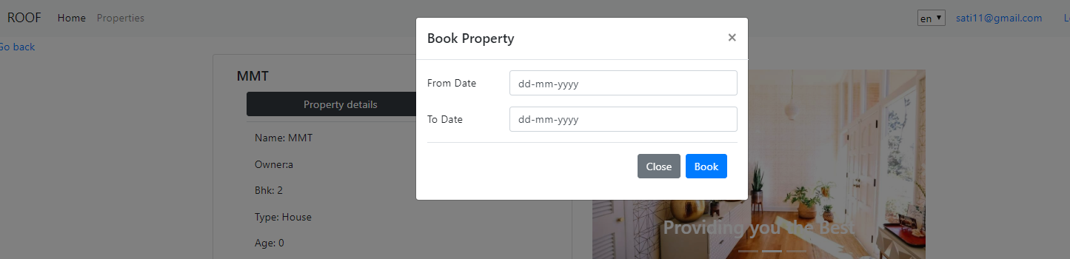

1. Profile:

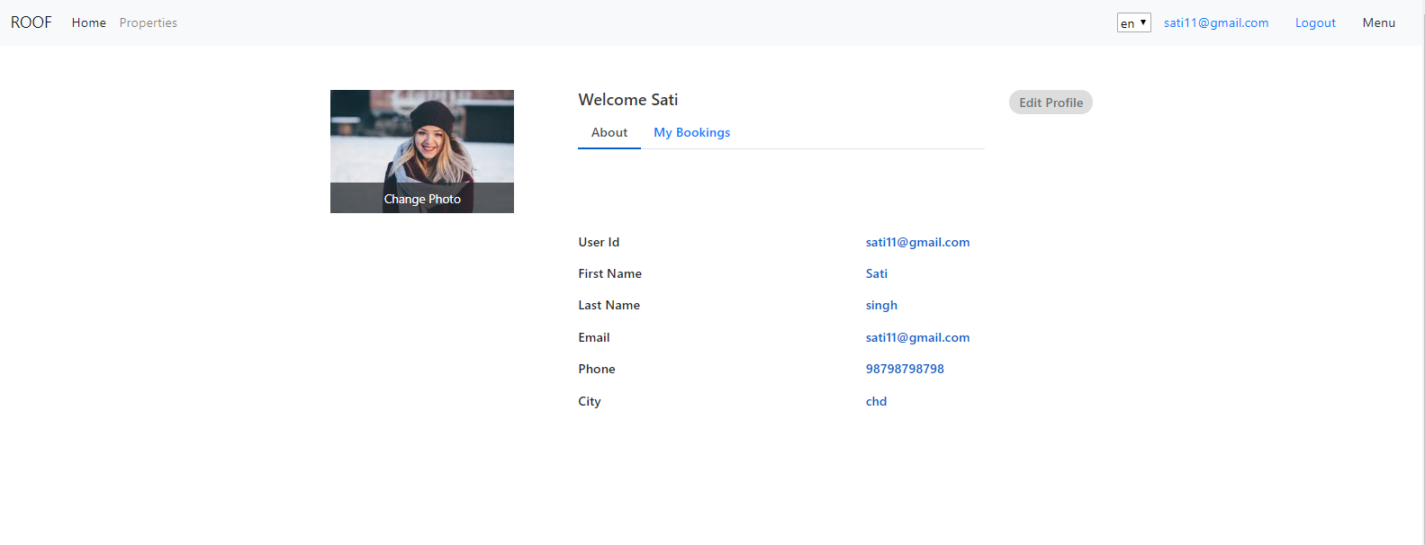

1. Edit Profile:

